**Class:** Final Year (Computer Science and Engineering)

**Year:** 2024-25 **Semester:** 1

**Course:** High Performance Computing Lab

PRN: 21510069

Name: Harsh Bankat Karwa

Batch: B3

**Practical No. 4**

**Exam Seat No:**

**Title of practical:**

Study and Implementation of Synchronization

**Problem Statement 1:**

# Analyse and implement a Parallel code for below programs using OpenMP considering synchronization requirements. (Demonstrate the use of different clauses and constructs wherever applicable)

# Fibonacci Computation:

**Screenshots:**

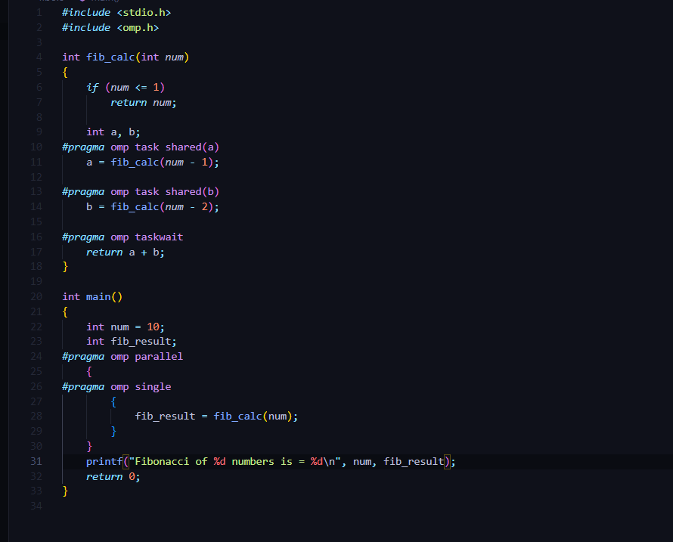



**Information:**

**Problem Statement 2:**

# Analyse and implement a Parallel code for below programs using OpenMP considering synchronization requirements. (Demonstrate the use of different clauses and constructs wherever applicable)

## Producer Consumer Problem

**Screenshots:**

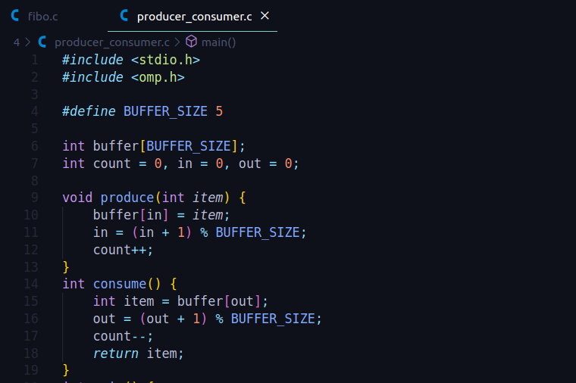

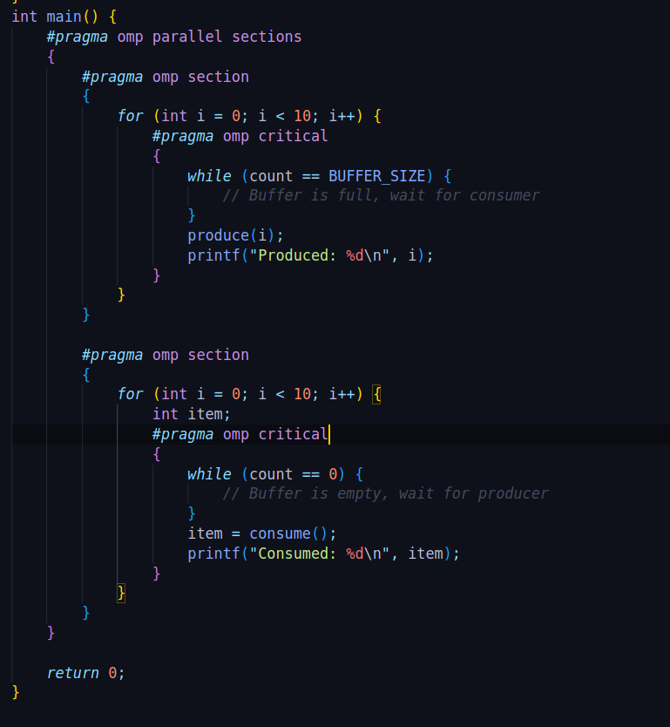

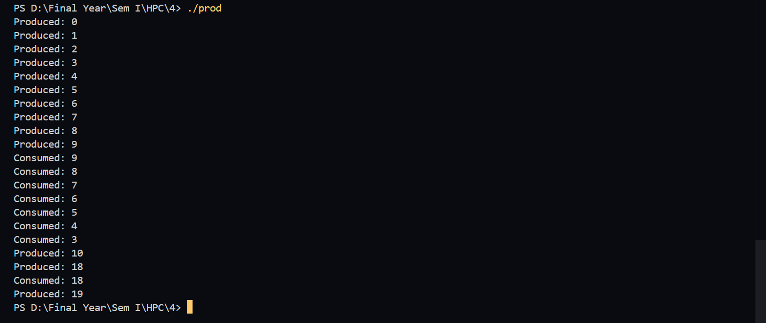**Information:**

**Github Link:**

[**https://github.com/harsh-1503/High-Performance-Computing**](https://github.com/harsh-1503/High-Performance-Computing)